Fall 2014

Multi-Techniques (MTec) Exercise
(Introduction to Standard Operating Procedures (SOPs)
and Good Laboratory Practices (GLPs))

INSTRUCTIONS

- Print the following pages and bring to the lab for the Multi-techniques (MTec) Exercise.

- Complete the cost per unit column that you will find in the “LOCKER ASSIGNMENT AND MATERIALS SHEET” before coming to the laboratory.

- Bring to lab the following items (may keep in locker):

  - Detergent/soap (jabón)
  - Paper Towels (papel toalla)
  - Nitrile gloves (guantes)
  - Lab Coat (bata)
  - Lab Goggles (gafas)
  - Lab Notebook (libreta de laboratorio)
  - Combination Lock (candado de combinación)
  - Labels or Masking Tape
  - Permanent Markers (Sharpies)
Experiment 1: Introduction to Standard Operating Procedures (SOPs) and
Good Laboratory Practices (GLPs)

EXTRA CREDIT WORKSHEET (15 pts)
Fall 2014

Student: _________________________________ Date: _________________________

Section: ____________________ Locker #:______________________
Instructor:________________________________ Combination: __________________

Exercise 1: Gravimetric Analysis (6 pts)

1A. Fill the following table with the information gathered: (3 pts)
SAMPLE | AVERAGE MASS (g) | STANDARD DEVIATION (g)
Standard _______ g weight (n =7)

In the box below show your calculations for the Average Mass and Standard Deviation: (2 pts)

1B. Not required on this inform. This data will be used for the next Experiment (“Using the Computer for Data Analysis”).

1C. Weight by difference data (1pt):

SAMPLE | Mass
Initial Mass of the weighting bottle +sample (g)
Final mass of the weighting bottle +sample (g)
Mass of the sample transferred (g)

Exercise 2: Volumetric Analysis (5 pts)

Water Temperature: ____________ Correction: _________________________

Fill the following table with the information gathered: (3 pts)
SAMPLE | AVERAGE | STANDARD DEVIATION
Delivered Mass (n=3)
Delivered Volume (n=3)

Include an example of how you calculated the “Delivered Volume” from the “Delivered Mass” data: (2 pt)

Exercise 3: Quantitative Transfer (4 pts)

- Write the reaction that produces the compound identified in (a).

- Identify the compound responsible for the white colloid you might have observed after performing the quantitative transfer test.

- Indicate the number of rinses carried out to ensure quantitative transfer for the:

Graduate cylinder: _____________
uNIVERSITY OF PUERTO RICO MAYAGUEZ
DEPARTMENT OF CHEMISTRY
ANALYTICAL CHEMISTRY LABORATORY
QUIM ___________ Fall 2014

LOCKER ASSIGNMENT AND MATERIALS SHEET

Equipment/Materials in Locker:
Item # | Description | Amount / Cost per unit* |  | Illustration
1 | Rubber Policemen (Agitadores con policías) | 3  $___________ |  | 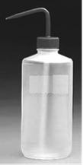
2 | Plastic Wash Bottle (500 mL) | 1 |  | 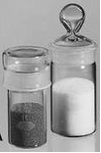  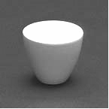
3* | Weighing Bottle | 2
4* | Crucibles (Crisol) with Caps (porcelain) | 3 |  | 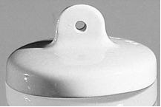  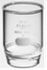
5* | Sintered Glass Crucible (for filtration) | 3
6 | Rubber crucible holder (adaptador para crisoles) | 1 |  | 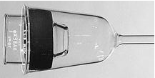
7 | Watch Glasses (90mm) | 3 |  | 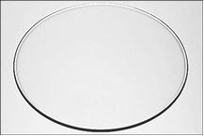
8 | Watch Glasses (115 mm) | 3
9 | Desiccator (glass)-200 mm diameter  - cover (only)…………………..  - complete……………………… | 1  $  $ |  | 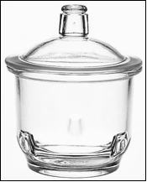
10 | Filtering Funnels (Embudos de Tallo Largo) – ( 55 mm diameter) | 3 |  | 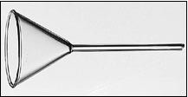
11 | Florence Flasks (Flat-Bottom Boiling Flasks) 500 mL | 1 |  | 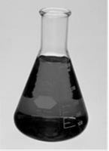  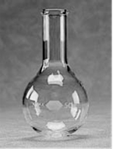  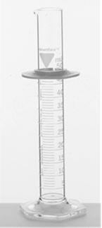
12 | Florence Flasks (Flat-Bottom Boiling Flasks) 1000 mL | 1
13 | 300 mL Erlenmeyer flasks | 3
14 | 500 mL Erlenmeyer flasks | 3
15 | Graduated cylinder -10 mL (probeta) | 1
16 | Graduated cylinder 100 mL | 1
17 | Glass Beakers - 150 mL (reusable) | 3 |  | 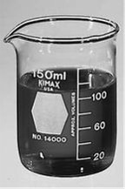
18 | Glass Beakers - 250 mL | 3
19 | Glass Beakers – 400 mL | 3
20 | Glass Beakers - 600 mL | 3
21 | Spatula | 1 |  | 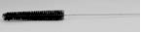  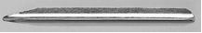
22* | Buret Brush (cepillo) | 1
23 | Glass Medicine Dropper-straight tip (3” length) (Gotero) | 1 |  | 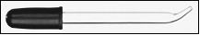
24* | Buret (50 mL) | 1
25* | Analytical balance (max 110g or 210g, d= 0.1 mg) | 1
Total cost:** (Fisher Scientific or Sigma-Aldrich) |  |  | $

*Note: The following items will not be available or located inside your locker: #3, #4, #5, #22, #24, and #25

Additional Material the student must have in lab / to keep in locker:
Detergent/soap (jabón) Paper Towels (papel toalla) Nitrile gloves (guantes) Permanent Markers
Lab Coat (bata) Lab Goggles (gafas) Labels or Masking tape

CERTIFICATION
I have verified the contents of my locker and have replaced and/or obtained any damaged or missing items. I certify that my locker contains the equipment listed above and that I am responsible for it. At the end of the semester, or if I drop the course, I will clean all the equipment and leave the locker contents as received.

Name: _____________________________________ Locker Number: _____________
Student ID #: ________________________________ Lab Room: _________________
Section: ____________________________________ Instructor: __________________

Student’s Signature (Firma): _____________________________ Date (Fecha):_________________

Instructor’s Signature: __________________________________

